ICGTETA’25 – International Conference on Global Trends in Engineering and Technological Advancement
DATE: 23/06/2025 (Online)
TIME: 9.00am to 3.00pm (23/06/2025)
THEME: Technological Excellence for Inclusive and Sustainable Development
ORGANIZED BY: Gojan School of Business and Technology
ASSOCIATE PARTNER: M/s VIPS.Tech

CHIEF GUEST DETAILS
SNO | NAME/DESIGNATION | MODE | PHOTOS
2 | Mr. Shubham Malhotra,  Software Engineer at Amazon AWS, New York City, USA. | Online | 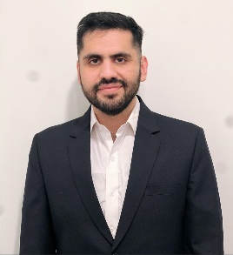
3 | Dr. Muthu S M,  KAIST University  Daejeon, South Korea | Online | 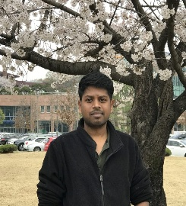

RESOURCE PERSON DETAILS
- Mr. Shubham Malhotra
Software Engineer at Amazon AWS, New York City, USA
Expertise: Cloud Computing, Software Engineering, Distributed Systems, Backend Development
Key Contributions:
• Led the integration of AI-driven monitoring tools to enhance cloud infrastructure observability.
• Implemented robust security protocols for distributed systems, ensuring data integrity and compliance.

OBJECTIVE
The objective of the International Conference on Global Trends in Engineering and Technological Advancement is to:
- Foster knowledge exchange among researchers, industry professionals, and students in the fields of engineering and technology.
- To provide a global platform for researchers, academicians, and industry professionals to present and exchange their innovative ideas in engineering and technological advancements.
- To explore emerging trends and breakthrough technologies shaping the future of various engineering disciplines.
- To foster interdisciplinary collaboration and knowledge sharing among experts from academia and industry across the globe.
- To promote research and innovation that addresses real-world challenges in sustainability, automation, and digital transformation.
- To showcase cutting-edge developments in areas like AI, IoT, cloud computing, renewable energy, smart systems, and more.
- To encourage young researchers and students to engage in high-quality technical research and contribute to technological progress.
- To build meaningful industry-academia linkages for future research partnerships, internships, and applied projects.
- To facilitate publication opportunities and recognition for significant research work through journals and conference proceedings.

AGENDA

Online Program Schedule:
- Welcome Address
- Keynote Speech
- Technical Session 1
- Lunch Break
- Technical Session 2
- Valedictory Function
- Vote of Thanks & Closing Remark

KEY OUTCOMES

Key Outcomes of ICGTETA’25 – International Conference on Global Trends in Engineering and Technological Advancement.
The ICGTETA’25 aims to serve as a premier international platform, bringing together researchers, industry professionals, academicians, and students to engage in meaningful discussions and share insights on global trends and transformative innovations in engineering and technology:
- Deepened Insight into Global Engineering Trends
- Fostering Multidisciplinary and Industry-Academia Collaboration
- Igniting Innovative Thinking and Technological Foresight
- Professional Growth and Technical Skill Advancement
- Showcasing Cutting-edge Research and Technological Demonstrations
- Creating Networking Avenues for Future Engagement
- Highlighting Challenges, Needs, and Future Research Directions
- Encouraging Prototype Development and Applied Engineering Solutions
- Raising Awareness of Technology’s Role in Societal Transformation
- Laying the Groundwork for Long-term Strategic Initiatives

BEST PAPER AWARD
Track 1:
- Customer Sentiment Analysis from Reviews Using NLP
Institution: Sree Muthukumarasamy College.
Presenters: Kirubakaran S
- AI based phishing website detection
Institution: TJS Engineering College
Presenters: Vishnu V
Track 2:
- Anomaly Detection in Network Traffic Using Autoencoders
Institution: Vel Tech Rangu Sangu Arts and Sciences.
Presenters: Dharshini V
- Product Recommendation Engine Using Collaborative Filtering
Institution: St. Thomas College of Arts and Science.
Presenters: Jagadev

PARTICIPANT DETAILS
ONLINE PARTCIPANTS:
TOTAL STUDENTS | 53
TOTAL PAPER COUNT | 53
STUDENT TEAMS | 37
STAFF | 16
TRACK 1 | 26 Teams
TRACK 2 | 27 Teams

ORGANIZING COMMITTEE
Chief Patron | Dr. Natarajan G,  Chairman,  Gojan School of Business and Technology.
Mrs. Brindha Natarajan,
Chairperson,
Gojan School of Business and Technology.
Mr. Viswanathan N,
Vice-Chairman,
Gojan School of Business and Technology.
Patron | Dr. Selvakumar C,  Principal,  Gojan School of Business and Technology.
Vice President | Dr. Arunsankar G,  Academic Affairs,  Gojan School of Business and Technology.
Mr. Ramadurai R,
Student Affairs,
Gojan School of Business and Technology.
Conference Chair | Dr. Nafeez Ahmed L,  Director – R & D,  Gojan School of Business and Technology.

INTERNATIONAL ADVISORY COMMITTEE
Dr. Ramu S,
Debre Tabor University, Ethiopia.

Dr. Muthu S M,
KAIST University, Daejeon, South Korea.

Mr. Shubham Malhotra,
Professor, Department of Master of Business Administration,
Gojan School of Business and Technology.

Dr. Sathish Kumar G,
Software Engineering, New York.

ADVISORY COMMITTEE
Dr. Amaladhasan S,
Professor, Department of Aeronautical Engineering,
Gojan School of Business and Technology.

Dr. Lakshmi Narayanan S,
Professor, Department of Electronics and Communication Engineering,
Gojan School of Business and Technology.

Dr. Christopher M,
Professor, Department of Master of Business Administration,
Gojan School of Business and Technology.

Dr. Sathish Kumar G,
Associate Professor, Department of Information Technology,
Gojan School of Business and Technology.

Dr. Thanalakshmi S,
Associate Professor, Department of Master of Business Administration,
Gojan School of Business and Technology.
Dr. Joseph Robinson M,
Assistant Professor, Department of Science and Humanities,
Gojan School of Business and Technology.
Dr. Premraj Y,
Assistant Professor, Department of Mechanical and Automation Engineering,
Gojan School of Business and Technology.
Dr. Parimala P,
Assistant Professor, Department of Science and Humanities,
Gojan School of Business and Technology.
Dr. Kokila V,
Associate Professor, Department of Master of Business Administration,
Gojan School of Business and Technology.
Dr. Vinoth Kumar G,
Assistant Professor, Department of Science and Humanities,
Gojan School of Business and Technology.

Dr. Vasantha Kumar G.R,
Assistant Professor, Department of Master of Business Administration,
Gojan School of Business and Technology.

COORDINATOR
Mr. Vinoth G,
Assistant Professor, Department of Mechanical and Automation Engineering,
Gojan School of Business and Technology.

VIPS.Tech
Mr. Dev Anand D,
Founder & CEO,
VIPS.Tech.
Mr. Lokesh K,
Co-Founder & Managing Director,
VIPS.Tech.
Ms. Snehavarshini S,
Editorial Team,
VIPS.Tech.
Ms. Kaviya M,
Technical Writer,
VIPS.Tech.

BROCHURE
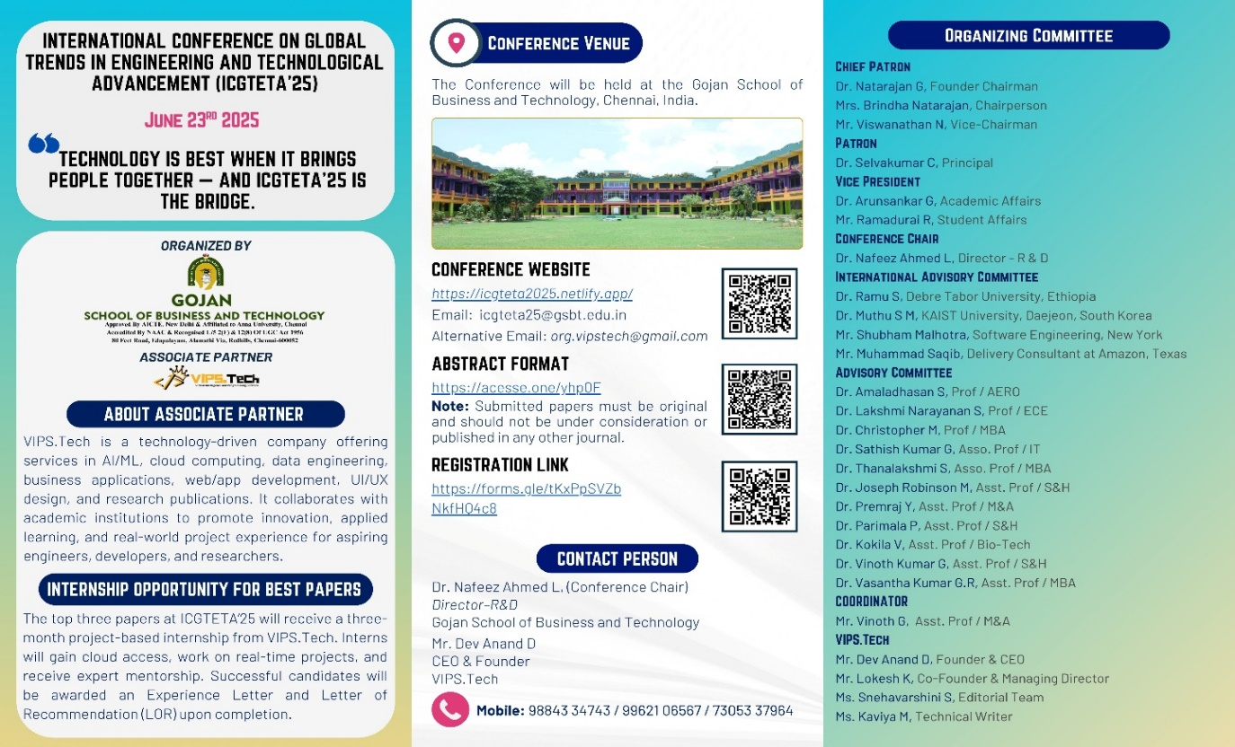
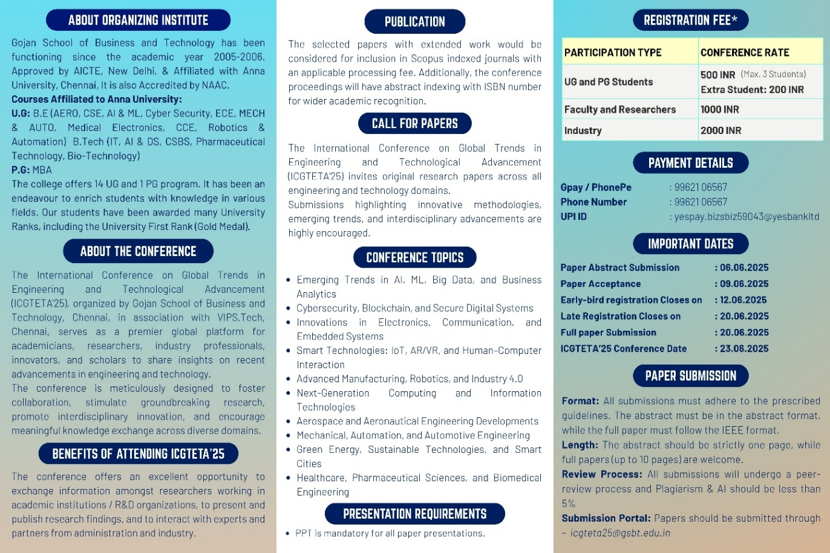

SOCIAL MEDIA
Instagram:
https://www.instagram.com/p/DLP-qC_zsW9/?igsh=MW9pMTQ0aDNwd2xsbQ==
LinkedIn:
https://www.linkedin.com/posts/vipstech_icgteta25-conferencesuccess-engineeringexcellence-activity-7342951666524004352-Lt7g?utm_source=share&utm_medium=member_android&rcm=ACoAAEBihnkBpUnOClurtuPZ7SR4q1uR1g2o1hI

PHOTOS

ONLINE CONFERENCE
TRACK 1
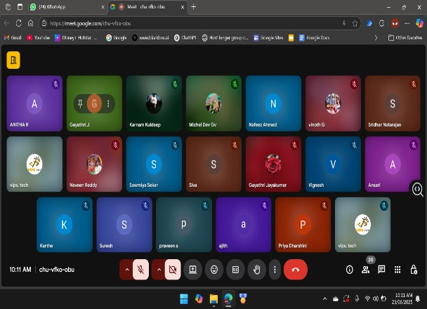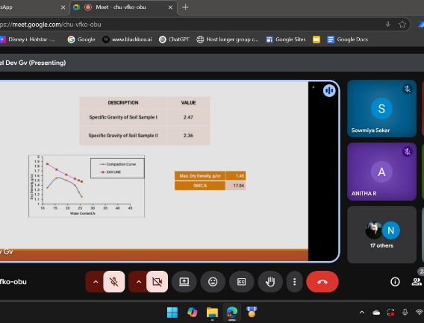
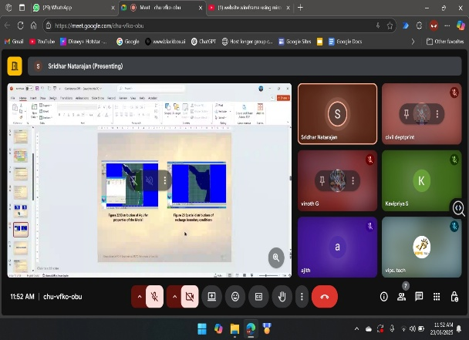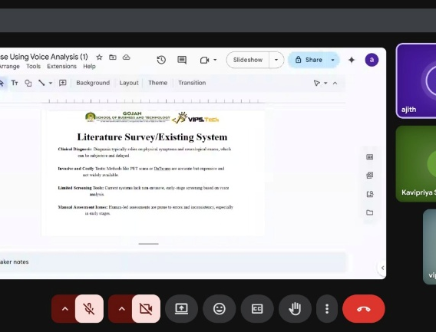
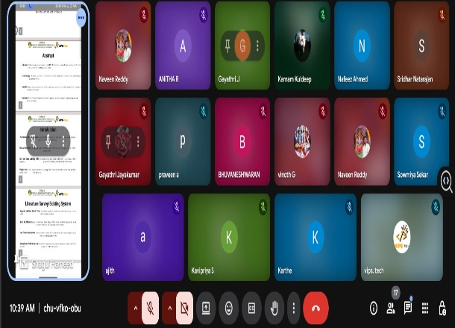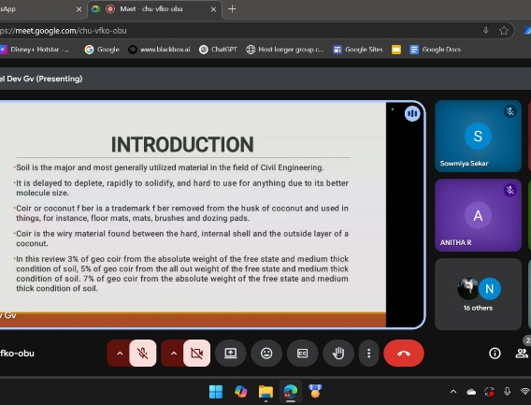
TRACK 2
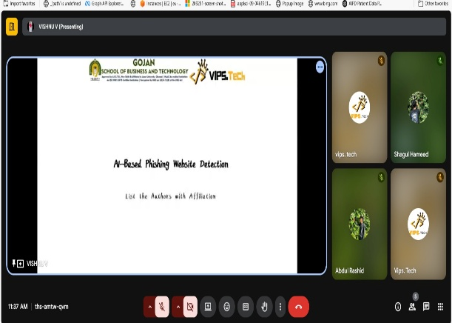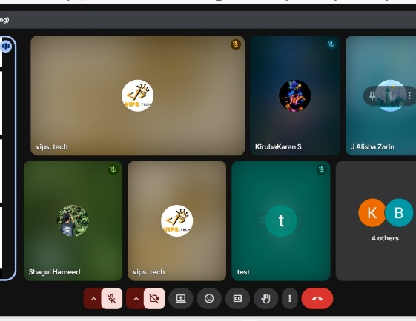
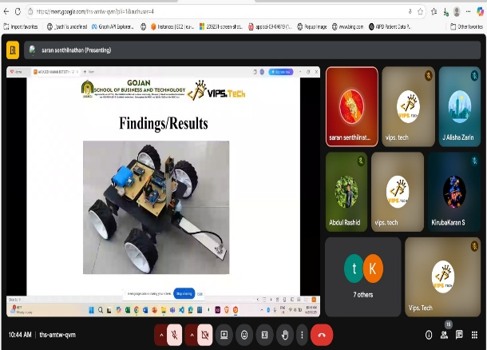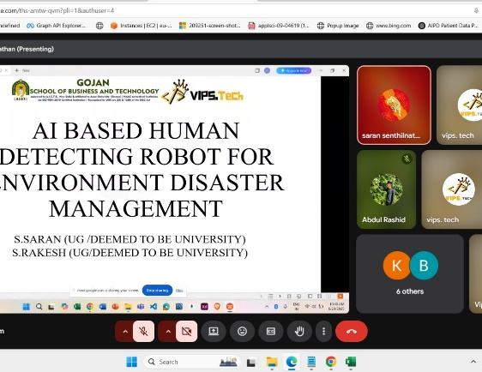
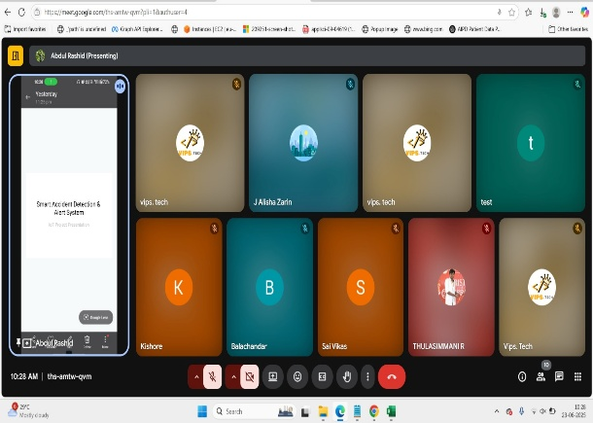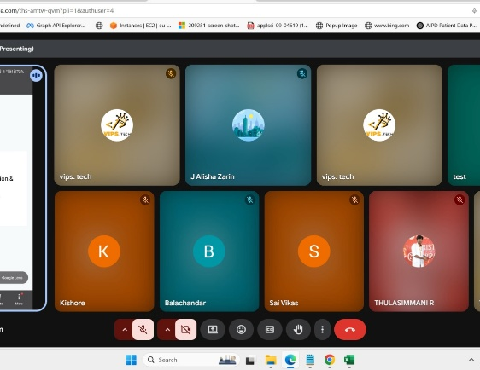

CONFERENCE INAUGRATION
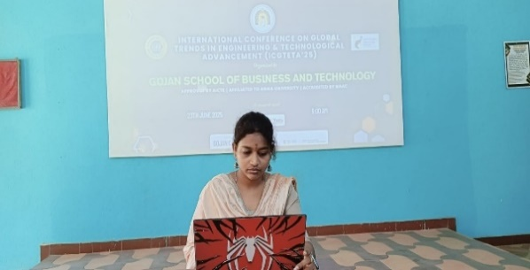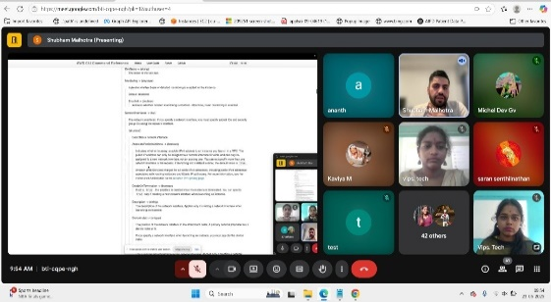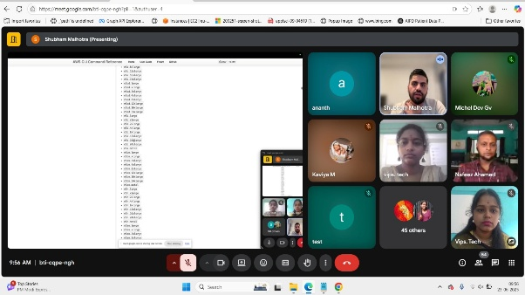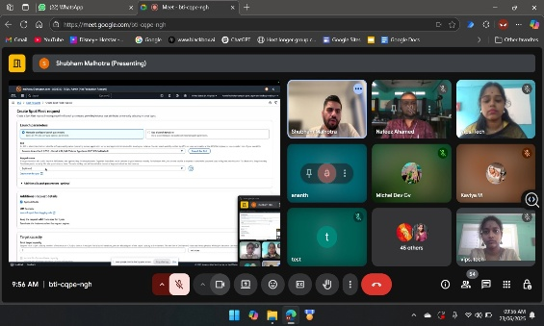
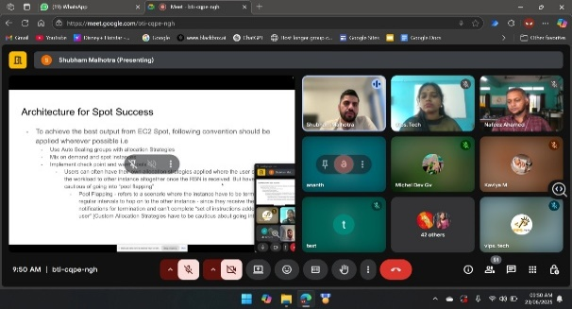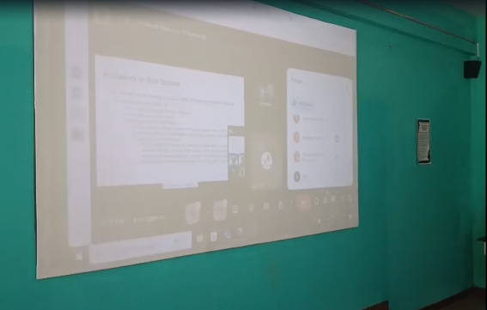
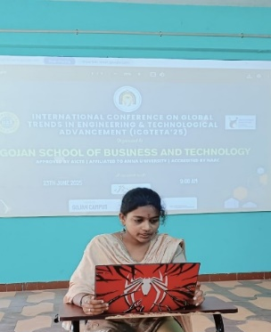
Prepared by:
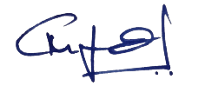  Dr. Nafeez Ahmed L  Director- R & D  Conference chair | 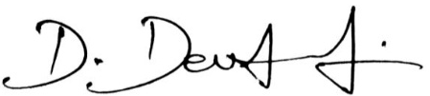  Mr. Dev anand D  CEO & Founder  VIPS.Tech
